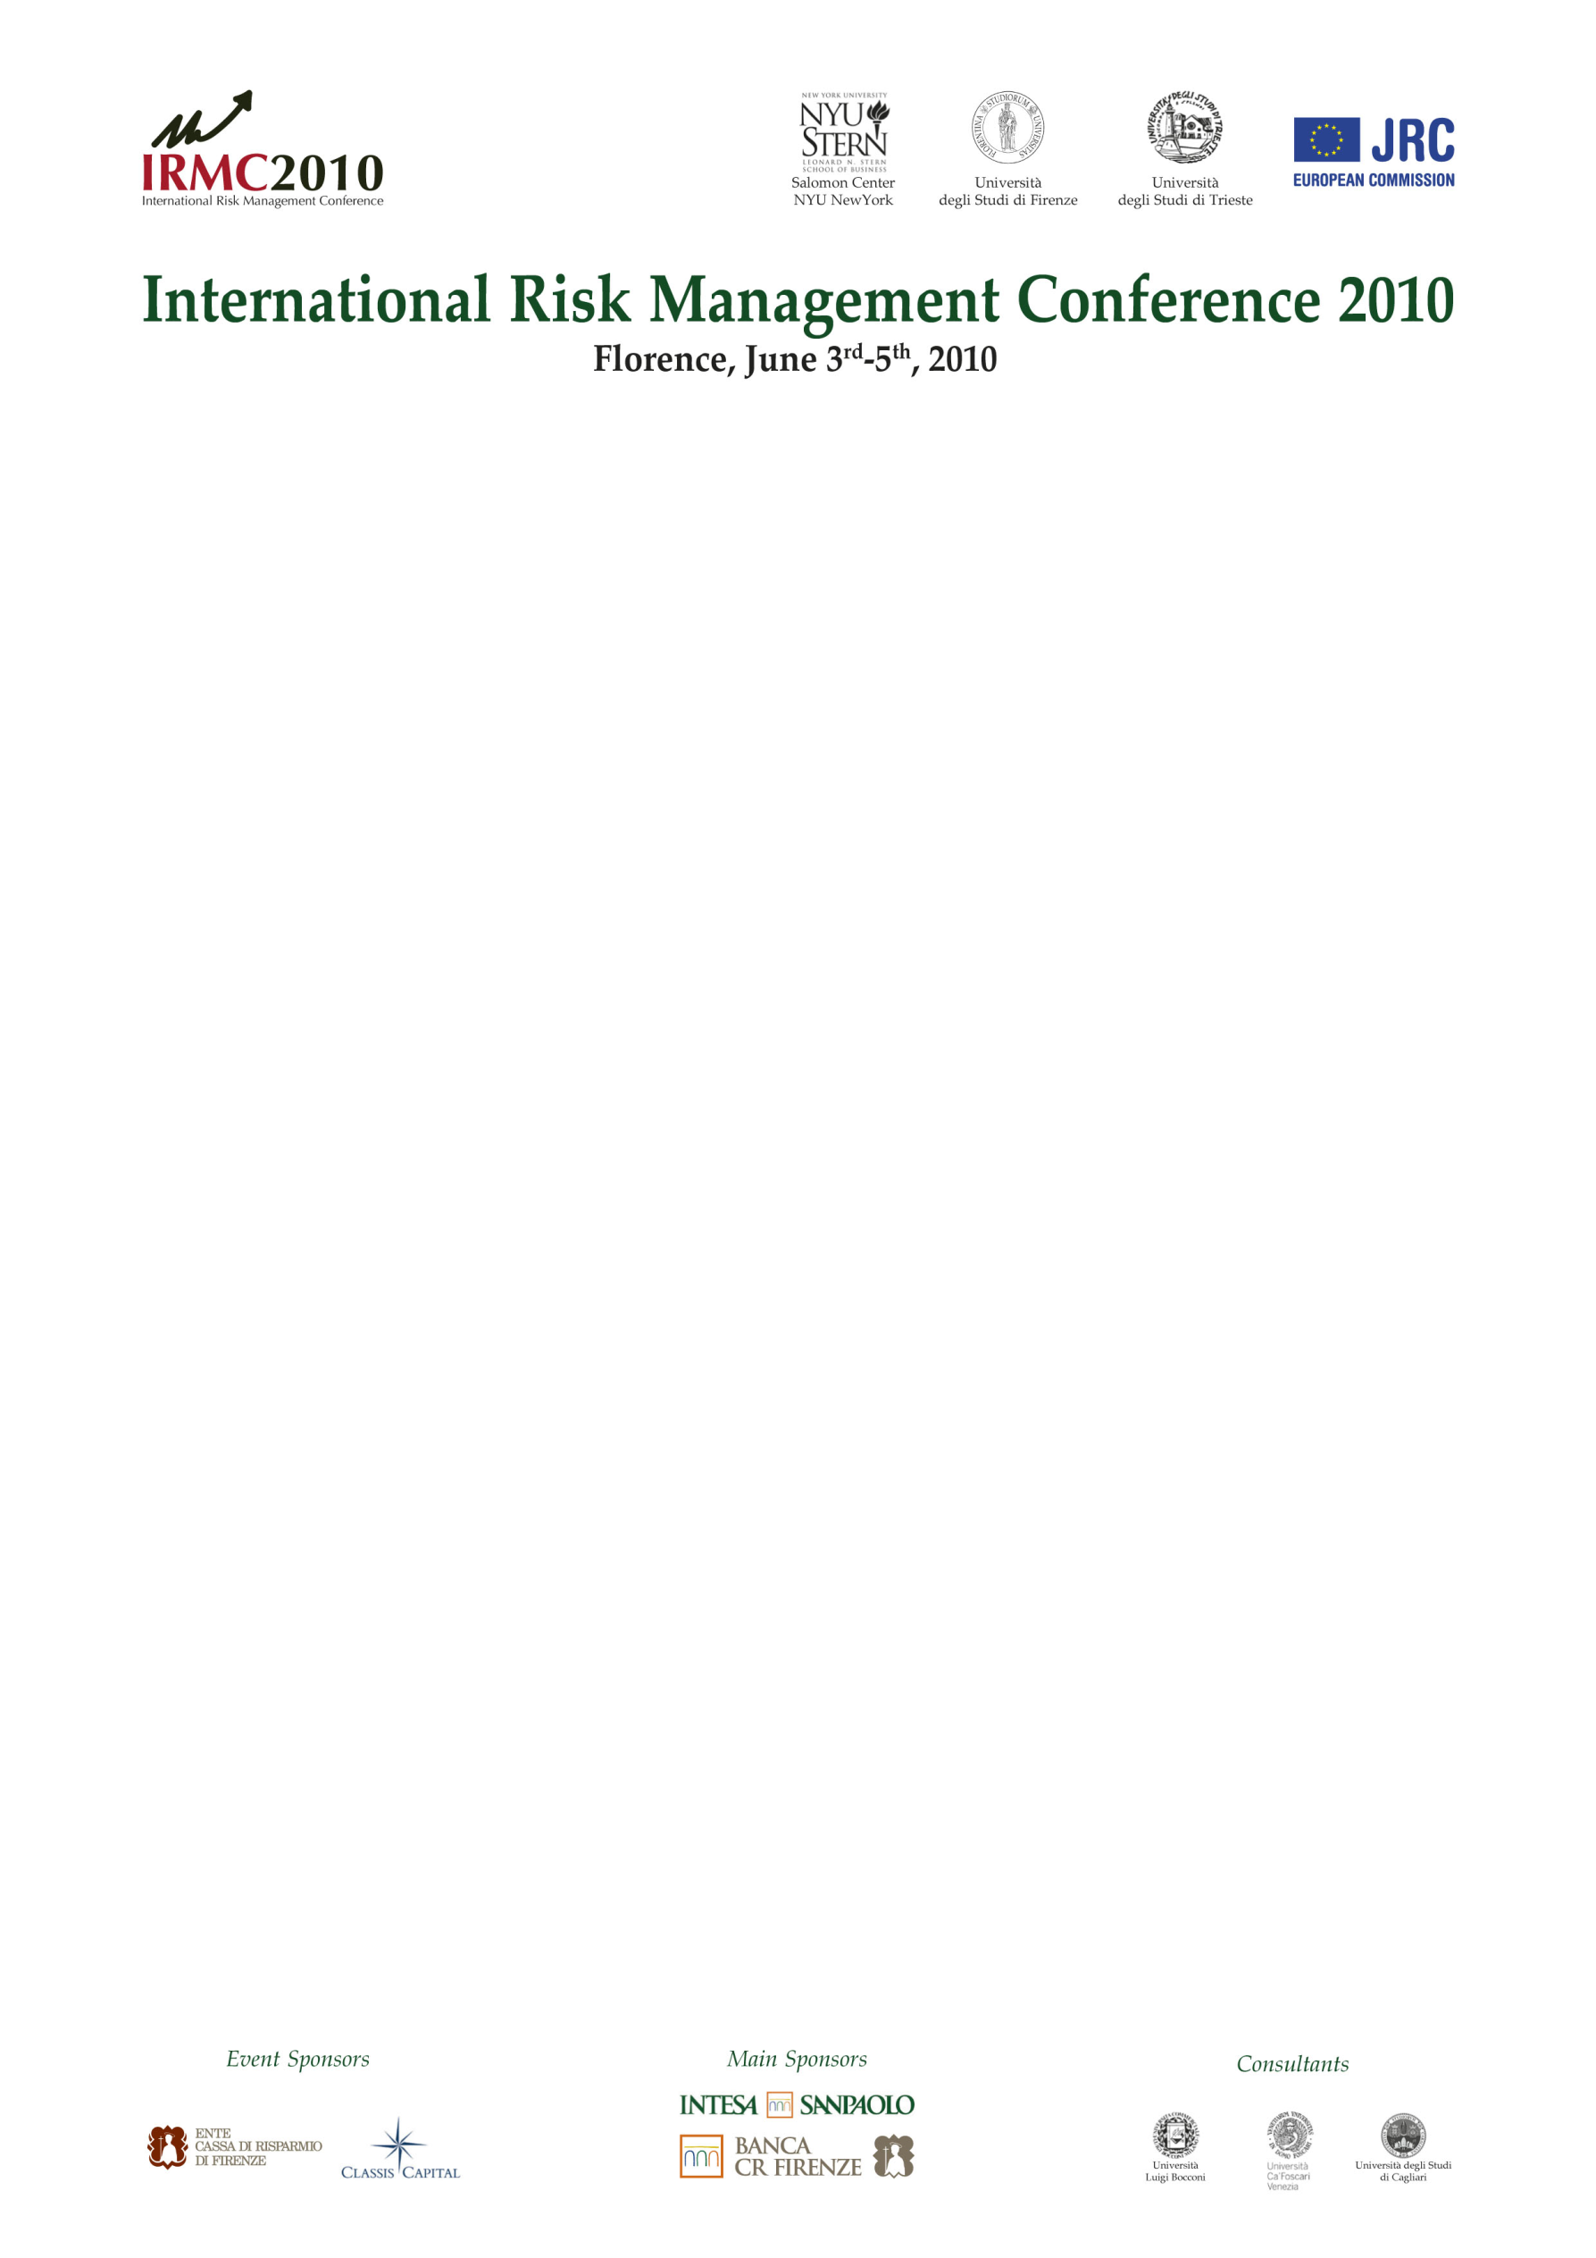

SHUTTLE SERVICE INFORMATION

There will be two bus pick-up points: the Piazza Santa Maria Novella (please see map on page 2) and in front of the Hilton Garden Inn Hotel.

Thursday June 3rd 2010:
- 13:00 one bus departs from Piazza Santa Maria Novella to Villa La Pietra.
- 13:30 one bus departs from Hilton Hotel to Villa La Pietra.
- 13:30 one bus departs Piazza Santa Maria Novella to Villa La Pietra.
- 13:45 one bus departs from Piazza Santa Maria Novella to Villa La Pietra.
- 14:00 one bus departs from Piazza Santa Maria Novella to Villa La Pietra.
- End of conference: buses depart from Villa La Pietra to Santa Maria Novella and Hilton.
- 19:45 buses departs from Piazza Santa Maria Novella and Hilton to CR Firenze Novoli.
- End of dinner: buses depart for Piazza Santa Maria Novella and the Hilton.

Friday June 4th 2010:
- 8:30 buses depart from Piazza Santa Maria Novella and the Hilton to Villa La Pietra.
- End of conference: buses depart from Villa La Pietra to SMN and Hilton.
- 19:45 buses depart from Piazza Santa Maria Novella and the Hilton to Villa La Pietra.
- End of dinner: buses depart for Piazza Santa Maria Novella and the Hilton.

Saturday June 5th 2010:
- 8:30 buses depart from Piazza Santa Maria Novella and the Hilton to Villa La Pietra.
- Closing of the conference: buses depart from Villa La Pietra to Piazza Santa Maria Novella and the Hilton.

Santa Maria Novella pick-up point

